**Documentation Art Program**

**Use cases**

**Creating color stripes**

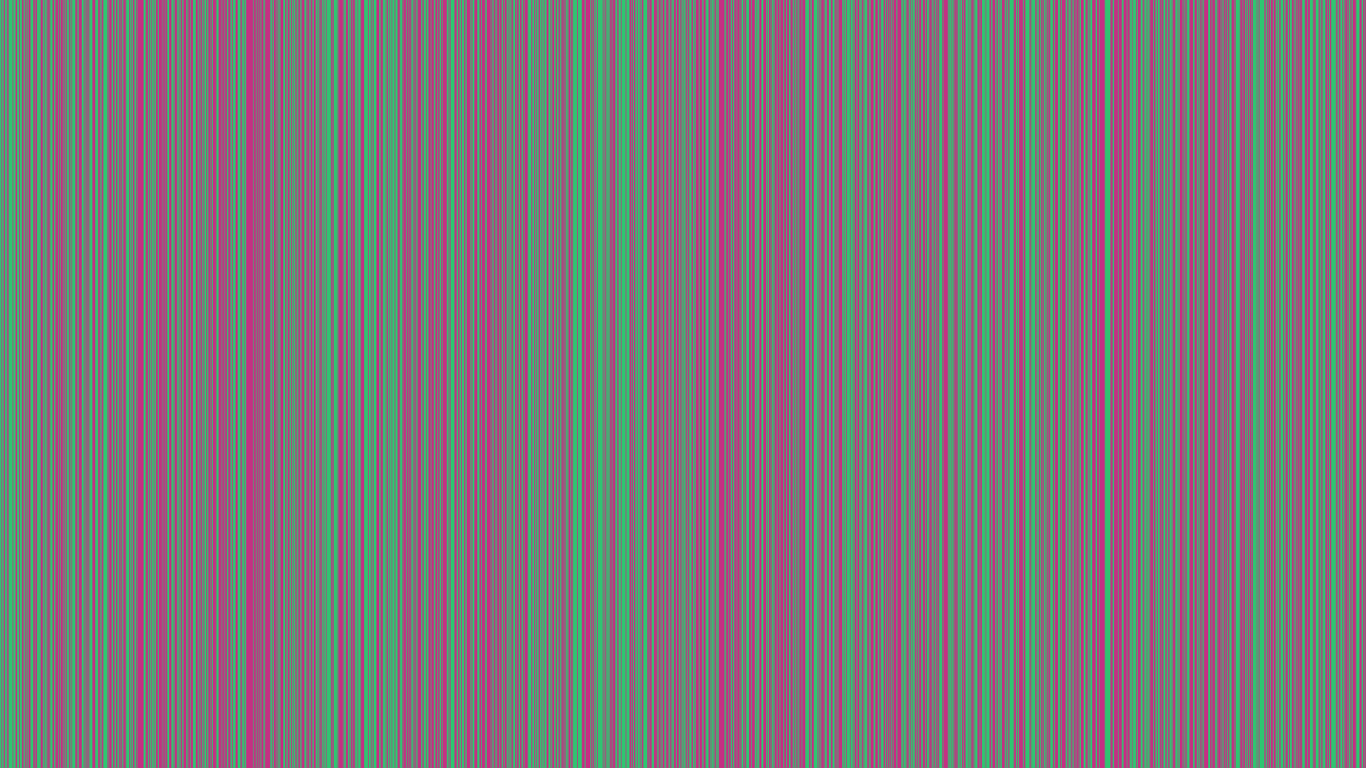The user is supposed to be able to create a picture with zebra stripes, the thickness is set by the user in pixels.

**Creating Layered Diamond Pictures**

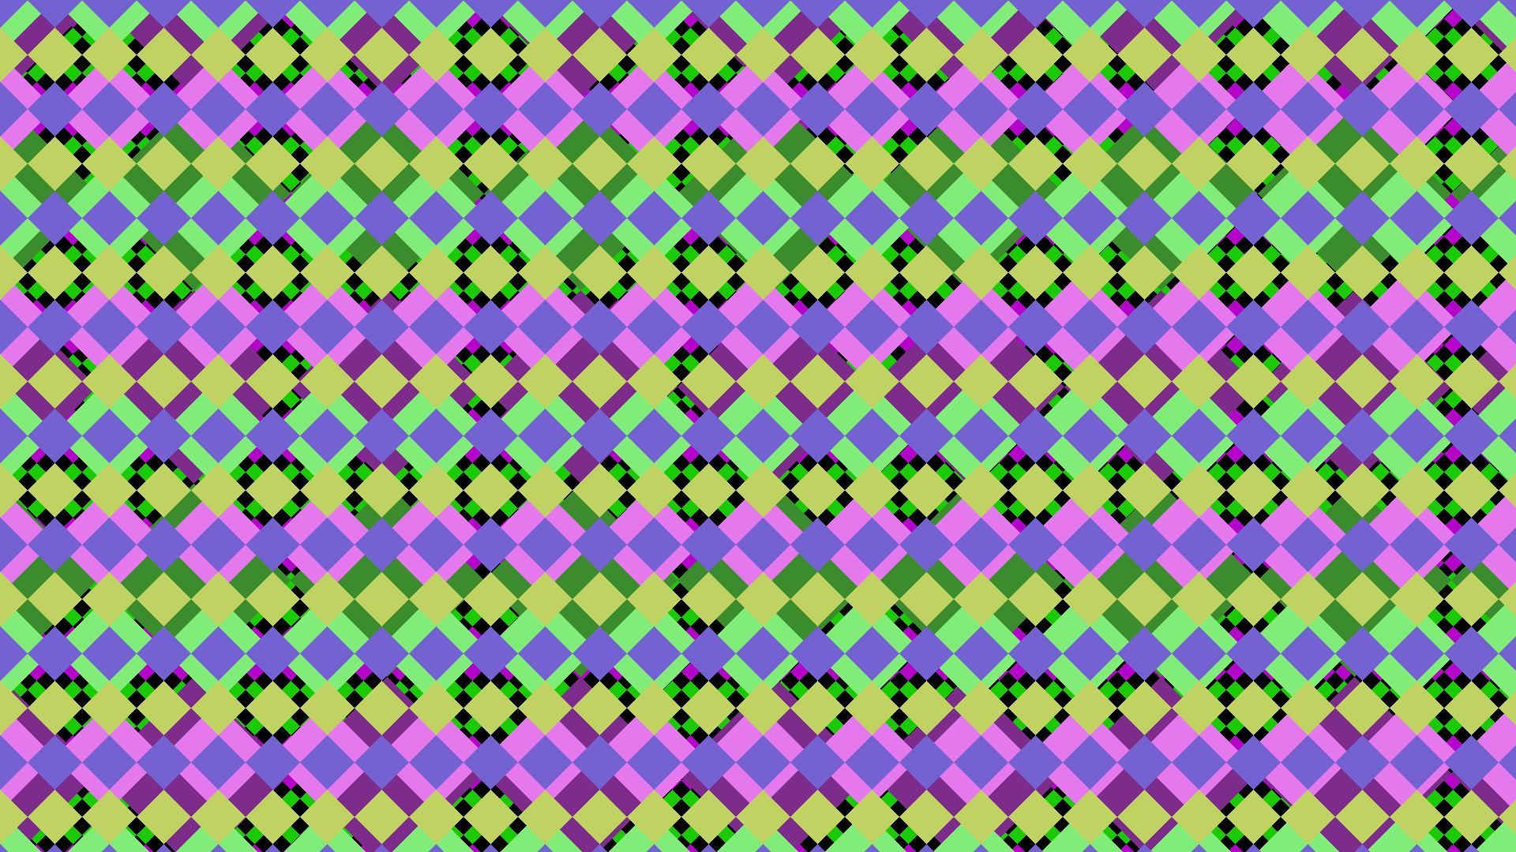The user can create layers upon layers of diamonds. He can define the side length of the diamond with an input and the diamonds will try to optimally fill out the picture.

**Creating color templates**

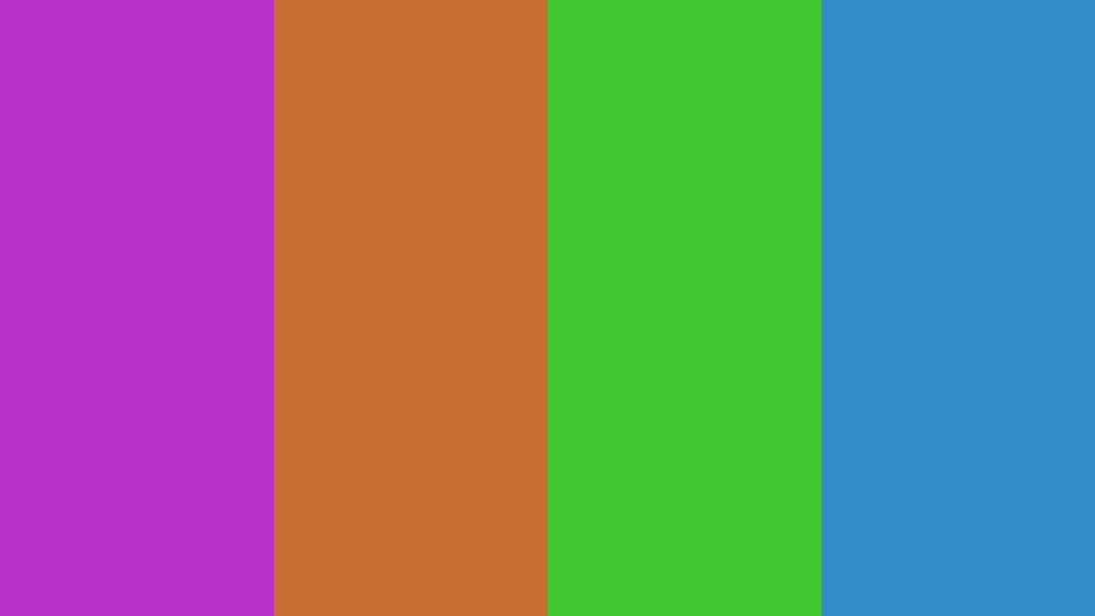The user is supposed to be able to generate random color templates, based on the user selected color scheme. The user should also be able to fine-tune certain color schemes if it makes sense in the terms of the theory, for example analogous would make sense, triadic wouldn't.

**Preparations**

**Deciding on a color scheme**

There should be a selection of the following color theories: analogous, tetradic, triadic and complementary color scheme.

A group of colorful circles

Description generated with low confidence*Analogous:*

Figure 1 Source: https://www.elledecor.com/design-decorate/color/a27793858/analogous-color-scheme/

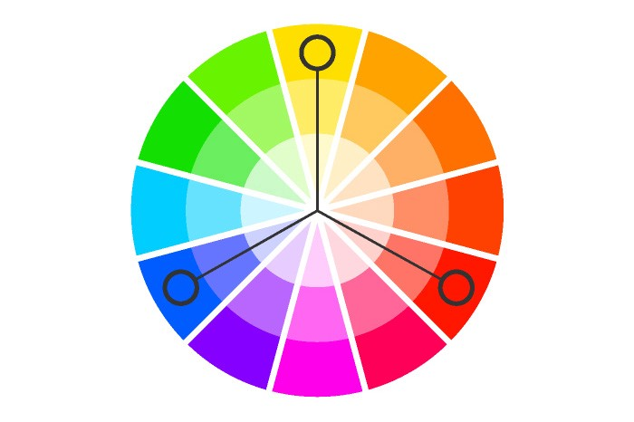*Triadic:*

Figure 2 Source: https://uxplanet.org/how-to-use-triadic-color-scheme-in-design-4b362206d7e8

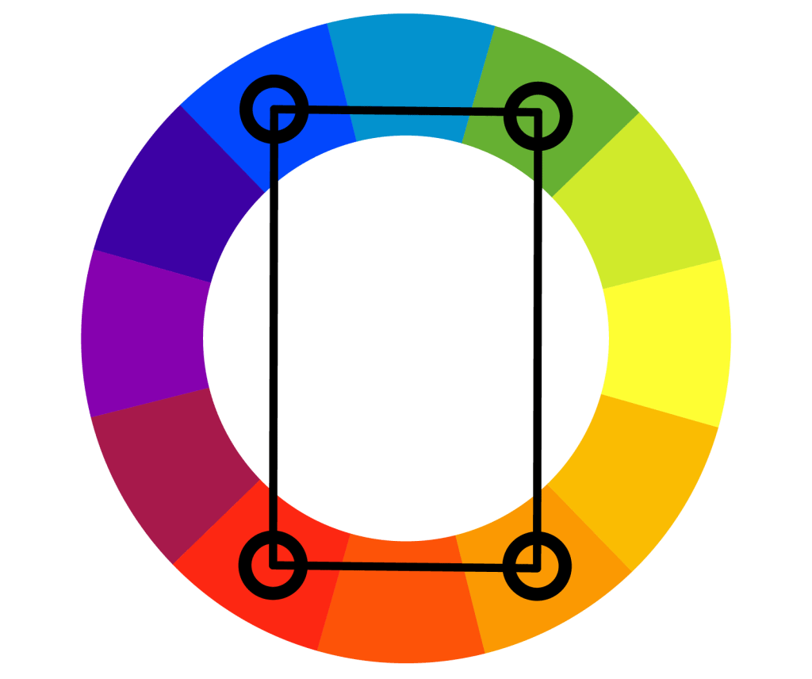*Tetradic:*

Figure 3 Source: https://www.color-meanings.com/rectangular-tetradic-color-schemes/

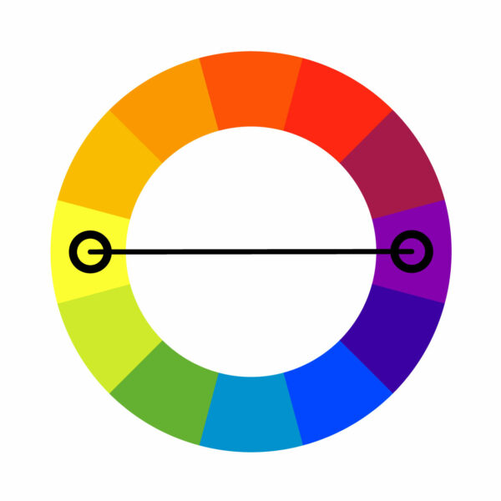*Complementary:*

**Calculations**

The hardest part is the generator for the diamonds. Their shape must be generated optimally, and I was searching for a formula to create their shape in an Instant so I tried some calculations, which I could use. To do that, I used Whiteboard and made some formulas.

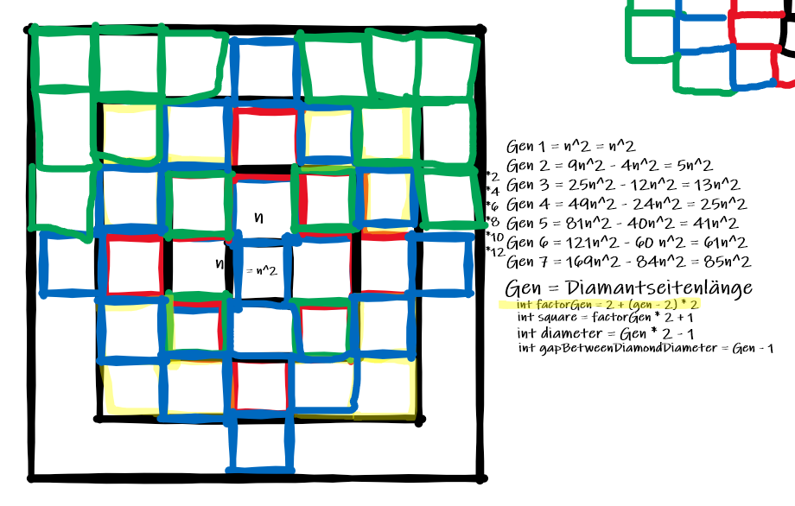In the end, I couldn't create them instantly as I wished but at least, I was able to minimize the loops needed using the formulas which I formed.

|  |  |
| --- | --- |
| **Variable** | **Value** |
| Gen (Generation Number) | Sidelength of the diamond (entered in parameter) |
| Area of the Diamond | Gen2 + (Gen – 1)2 |
| Diameter | Gen * 2 – 1 |
| Distance between diamonds | Diameter |